HW 1

Dataset 1:

Mean = 1.1857
Std Error = 0.0133
Std Dev = 0.4012

After changing to 500:
Standard error increased to 0.0181
Std Deviation increased to 0.4037

Would expect standard error and standard deviation to reduce and then converge as we increase size of data (since stddev is inversely proportional to size of data and standard error is directly proportional to stddev)

Dataset 2:

autocorr time = 19.7355
Std error without considering auto-corr = 1.03 E-4
Std error considering auto-corr = 0.0145

Dataset 3:
Mean with cutoff set to 0: -7.6507 and error 0.0281
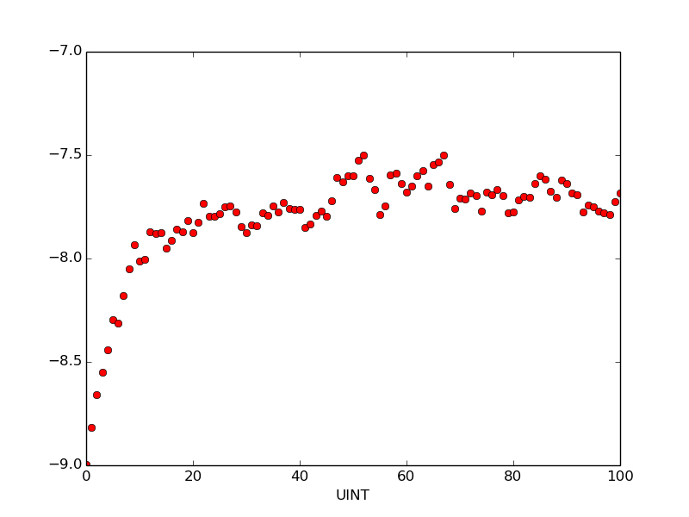
After plotting the first 100 items on the list one can see the transient ends near 15-20 and the curve flattens out after that.

So the best cutoff would be 20 or 15.

Mean with cutoff (20): -7.6375 and error 0.0211
Using the unpaired t test we can say that the difference is not quite statistically significant.

